| Cybersecurity |
| --- |
| Project 1 Technical Brief |

Make a copy of this document before you begin. Place your answers below   
each question. This completed document will be your deliverable for Project 1. Submit it through Canvas when you’re finished with the project at the end of the week.

## Your Web Application

Enter the URL for the web application that you created:

| https://mutasemssecurityblog.azurewebsites.net |
| --- |

Paste screenshots of your website created (Be sure to include your blog posts):

|  |
| --- |

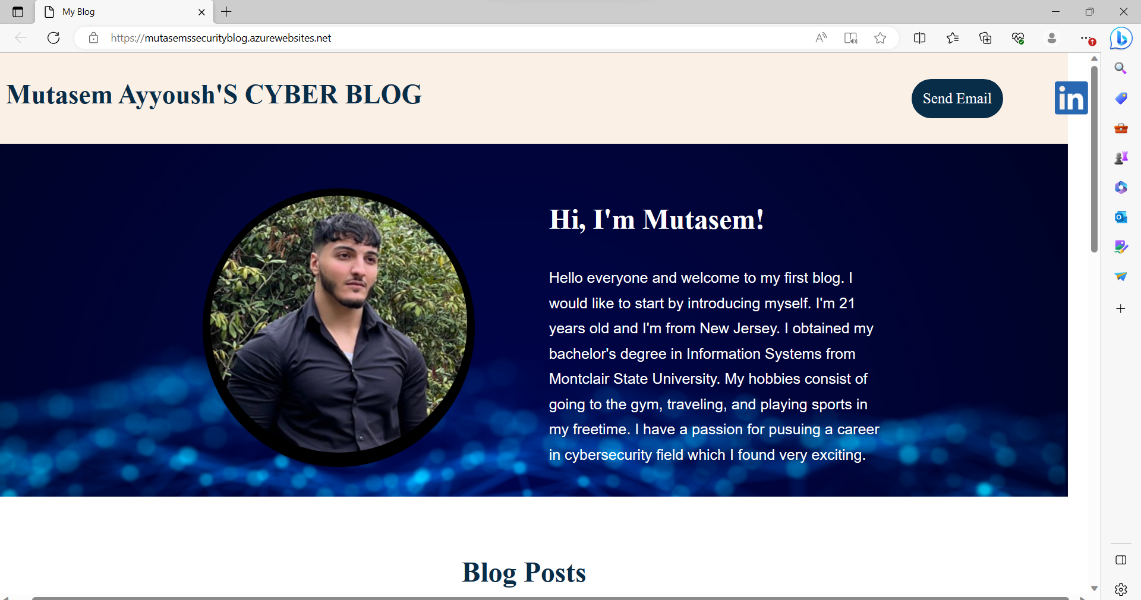

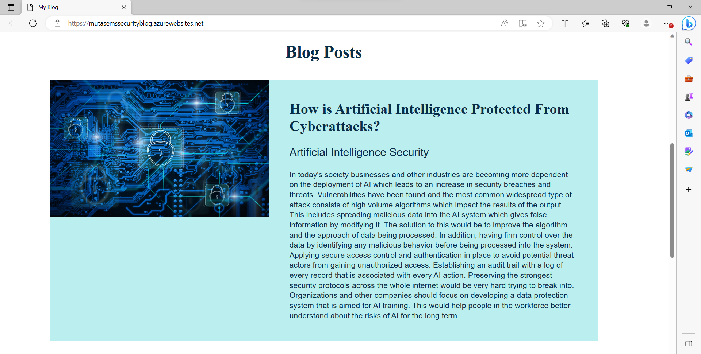

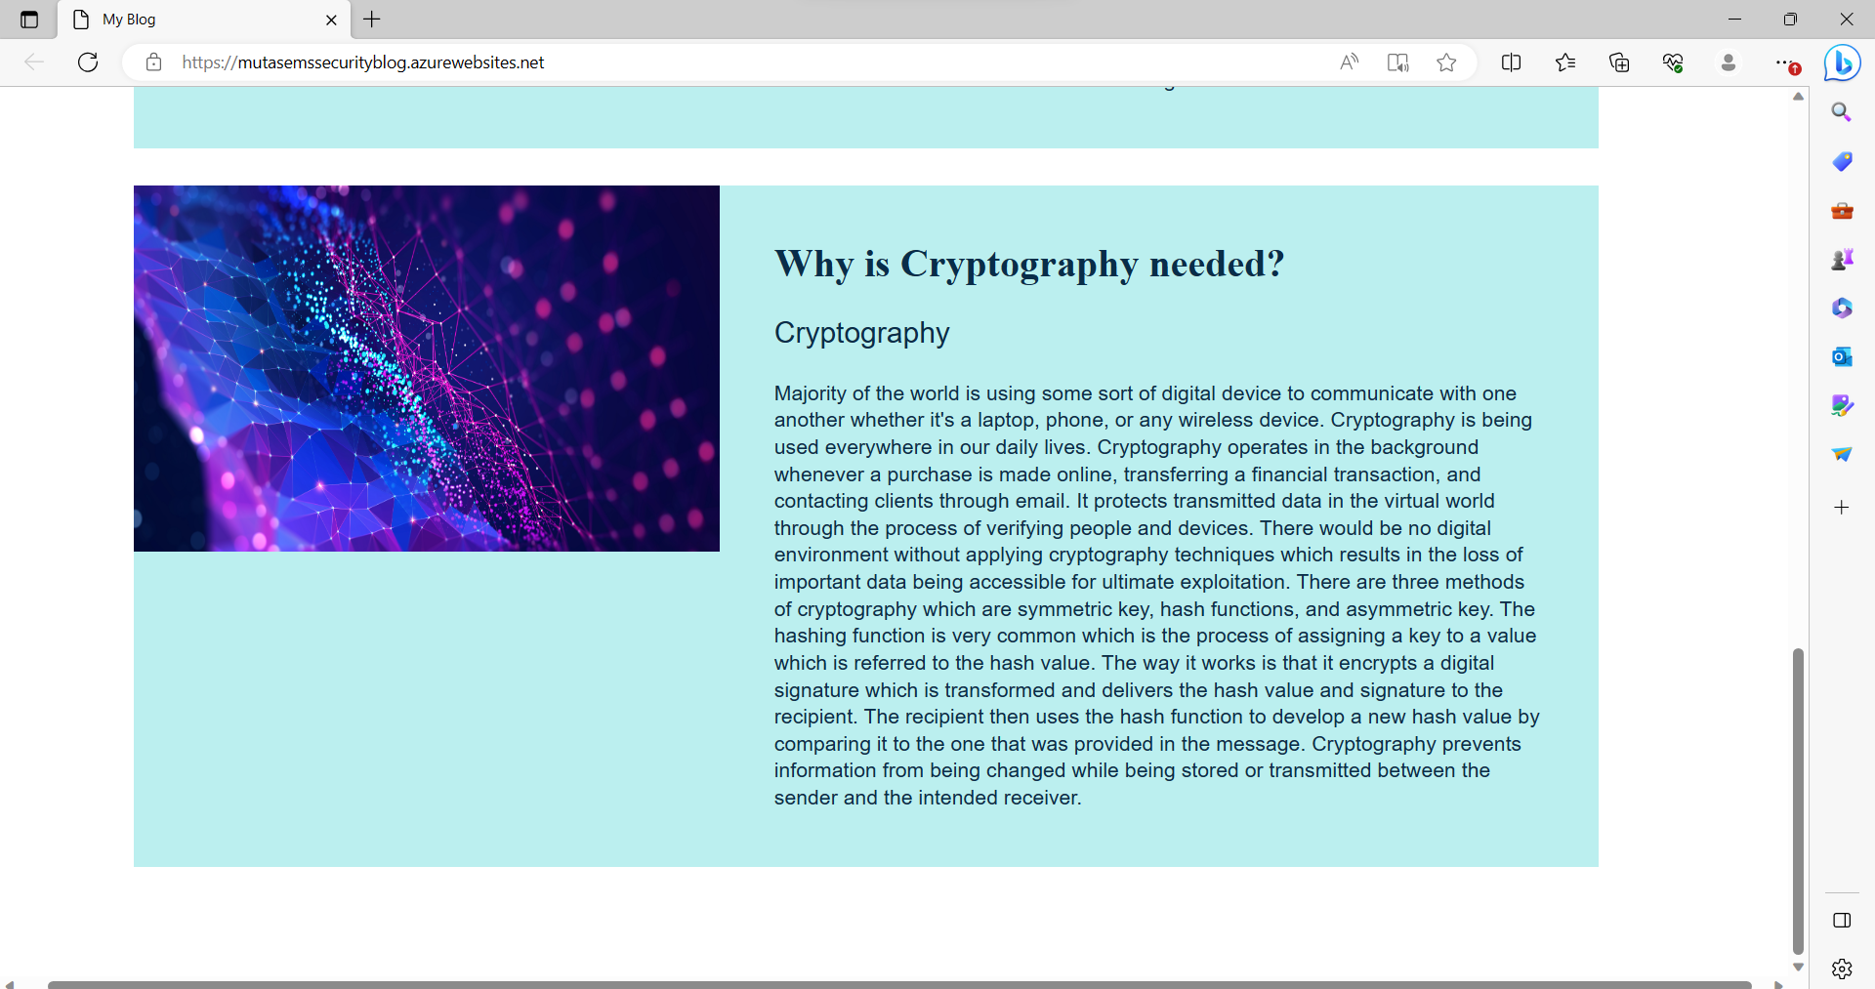

## Day 1 Questions

### General Questions

1. What option did you select for your domain (Azure free domain, GoDaddy domain)?

| Azure free domain |
| --- |

1. What is your domain name?

| mutasemssecurityblog.azurewebsites.net |
| --- |

### Networking Questions

1. What is the IP address of your webpage?

| 20.211.64.21 |
| --- |

1. What is the location (city, state, country) of your IP address?

| Sydney,New South Wales,Australia |
| --- |

1. Run a DNS lookup on your website. What does the NS record show?

|  |
| --- |

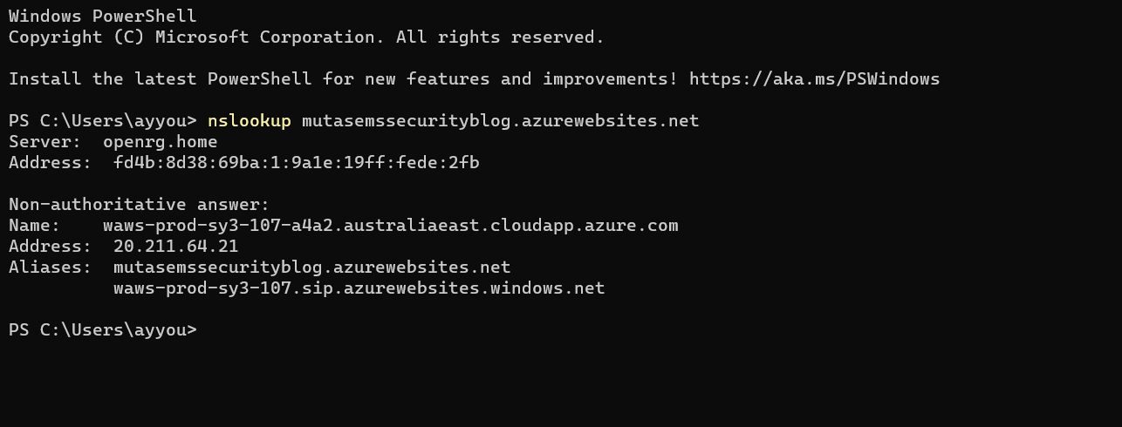

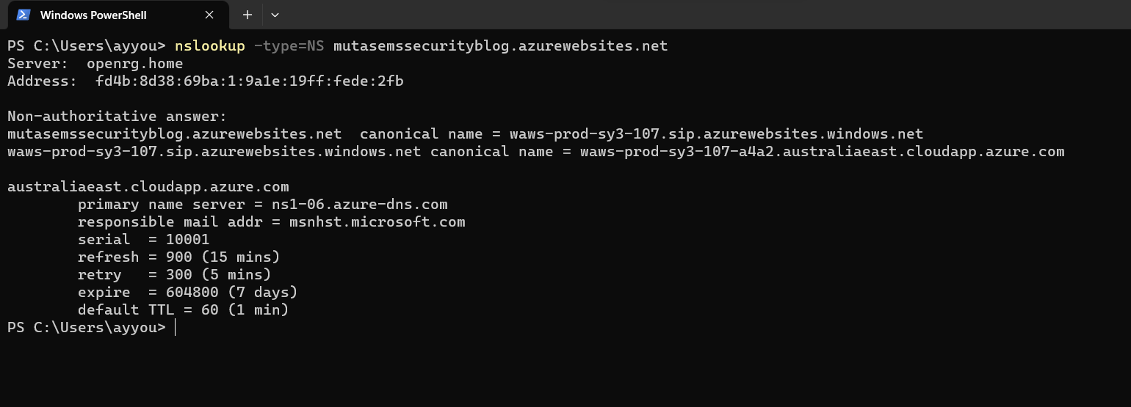

### Web Development Questions

1. When creating your web app, you selected a runtime stack. What was it? Does it work on the front end or the back end?

| Back end,PHP 8.0 |
| --- |

1. Inside the /var/www/html directory, there was another directory called assets. Explain what was inside that directory.

| There is a css and images folders. |
| --- |

1. Consider your response to the above question. Does this work with the front end or back end?

| Front end |
| --- |

## Day 2 Questions

### Cloud Questions

1. What is a cloud tenant?

| A cloud tenant is a sharing of virtual resources that is available to a public or private environment that is separated from other users and protected. |
| --- |

1. Why would an access policy be important on a key vault?

| It limits who has access to the keys and data kept in the vault. |
| --- |

1. Within the key vault, what are the differences between keys, secrets, and certificates?

| keys are used to encrypt and decode data.Secrets are any private data that must be kept private and safe, including API keys, connection strings, and passwords.Digital certificates are records which specify an entity's identification, such as a person or company. |
| --- |

### Cryptography Questions

1. What are the advantages of a self-signed certificate?

| They are easy handed out, low cost and can handle larger key sizes. |
| --- |

1. What are the disadvantages of a self-signed certificate?

| Vulnerabilities are more present.Web browsers and other programs cannot identify them as trusted certificates even though the certificate of the issuing organization is already trusted. It lacks the approval for the identity of the certificate issuer which is a security issue. |
| --- |

1. What is a wildcard certificate?

| It is a digital certificate type that is used to protect many subdomains within a single domain. As long as all of the subdomains fall under the same root domain, a single certificate may be used to protect any number of subdomains with a wildcard certificate. |
| --- |

1. When binding a certificate to your website, Azure only provides TLS versions 1.0, 1.1, and 1.2. Explain why SSL 3.0 isn’t provided.

| It has a vulnerability that could lead an attacker to decode data, such as authentication cookies. |
| --- |

1. After completing the Day 2 activities, view your SSL certificate and answer the following questions:
   1. Is your browser returning an error for your SSL certificate? Why or why not?

| Yes because the request is missing a Bearer or PoP token. |
| --- |

* 1. What is the validity of your certificate (date range)?

| 08/30/2023-08/29/2024 |
| --- |

* 1. Do you have an intermediate certificate? If so, what is it?

| Yes,​​Microsoft Azure TLS Issuing CA 01 |
| --- |

* 1. Do you have a root certificate? If so, what is it?

| Yes, DigiCert Global Root G2 |
| --- |

* 1. Does your browser have the root certificate in its root store?

| yes |
| --- |

* 1. List one other root CA in your browser’s root store.

| CN=Amazon Root CA 2,O=Amazon,C=US |
| --- |

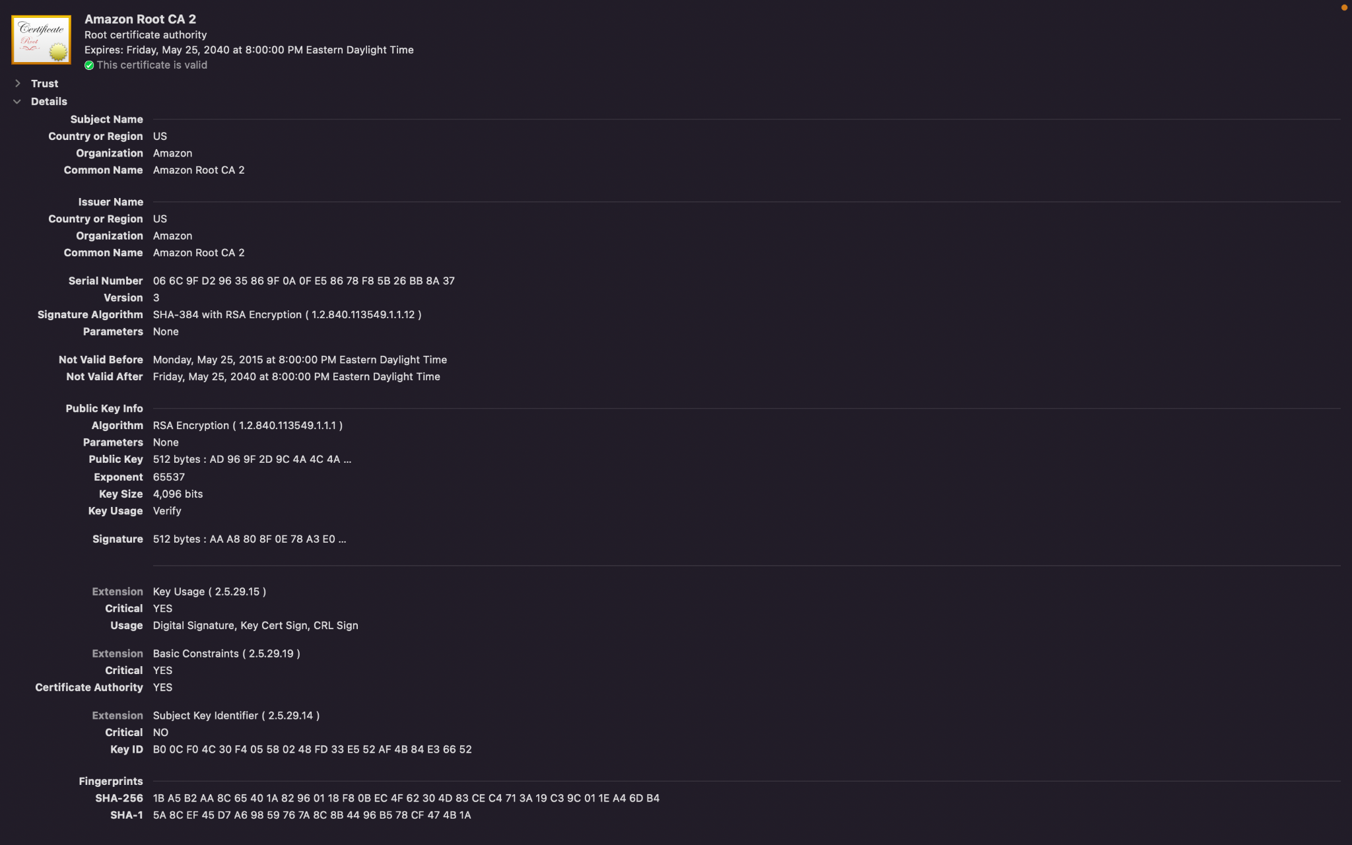

## Day 3 Questions

### Cloud Security Questions

1. What are the similarities and differences between Azure Web Application Gateway and Azure Front Door?

| Similarities:Both services provide load balancer capabilities which increases the capacity and availability of applications by sharing incoming traffic across many backend instances.Both have the ability to terminate SSL/TLS connections, which helps performance by transferring the encryption and decryption operations from the backend servers.  Differences:Azure web application Gateway does not have the essential storage and content delivery functionalities of Azure Front Door as well as worldwide content acceleration.Azure web application Gateway offers load balancing that is limited to a single area or availability zone while Azure Front Door offers load balancing worldwide by forwarding traffic based on delays, location, or other routing standards to the closest suitable backend. |
| --- |

1. A feature of the Web Application Gateway and Front Door is “SSL Offloading.” What is SSL offloading? What are its benefits?

| SSL Offloading is a process in which SSL (Secure Sockets Layer) decryption and encryption actions are carried out through a device such as a front door or web application gateway as opposed to the web server managing the traffic.The benefits include an increase level of security, improved performance, and cost-effectiveness. |
| --- |

1. What OSI layer does a WAF work on?

| Layer 7, Application layer |
| --- |

1. Select one of the WAF managed rules (e.g., directory traversal, SQL injection, etc.), and define it.

| SQL injection: malicious SQL statements are injected into the input field in order to compromise apps. |
| --- |

1. Consider the rule that you selected. Could your website (as it is currently designed) be impacted by this vulnerability if Front Door wasn’t enabled? Why or why not?

| Yes,because none of the rules would take place if the front door isn't enabled.The rule could reduce the threat caused by SQL injection and other web application vulnerabilities.A website is not completely secure. |
| --- |

1. Hypothetically, say that you create a custom WAF rule to block all traffic from Canada. Does that mean that anyone who resides in Canada would not be able to access your website? Why or why not?

| Yes because any IP address located within Canada can restrict access to my website for many users in Canada. However,someone that lives in Canada can hide their IP address by using a VPN to bypass the WAF rule and get access. |
| --- |

1. Include screenshots below to demonstrate that your web app has the following:
   1. Azure Front Door enabled

|  |
| --- |

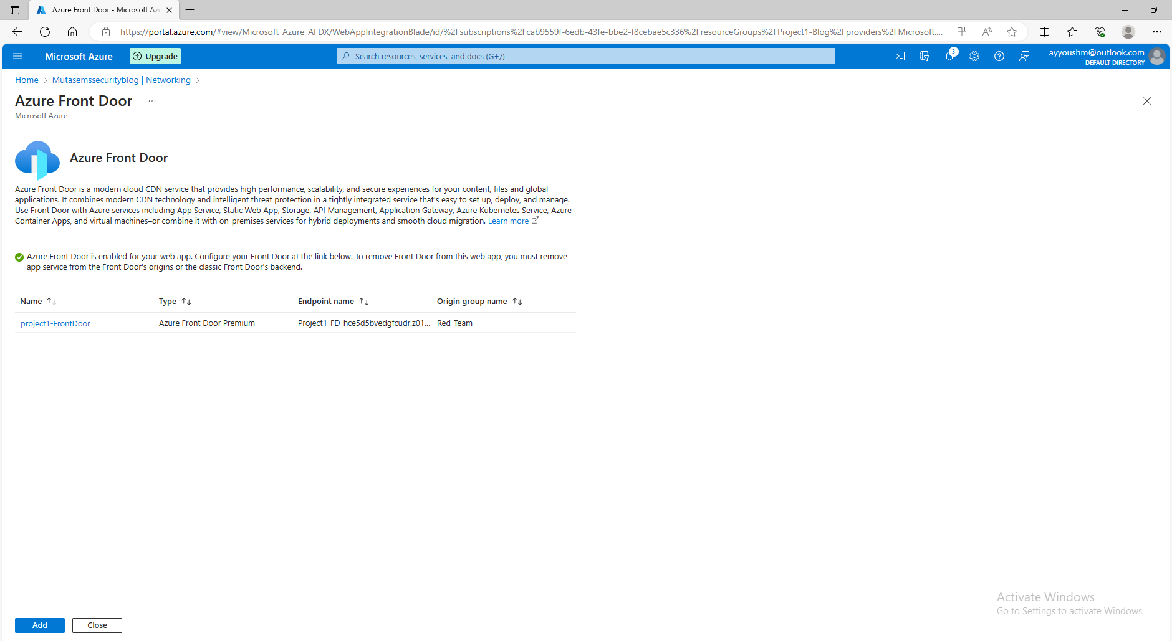

* 1. A WAF custom rule

|  |
| --- |

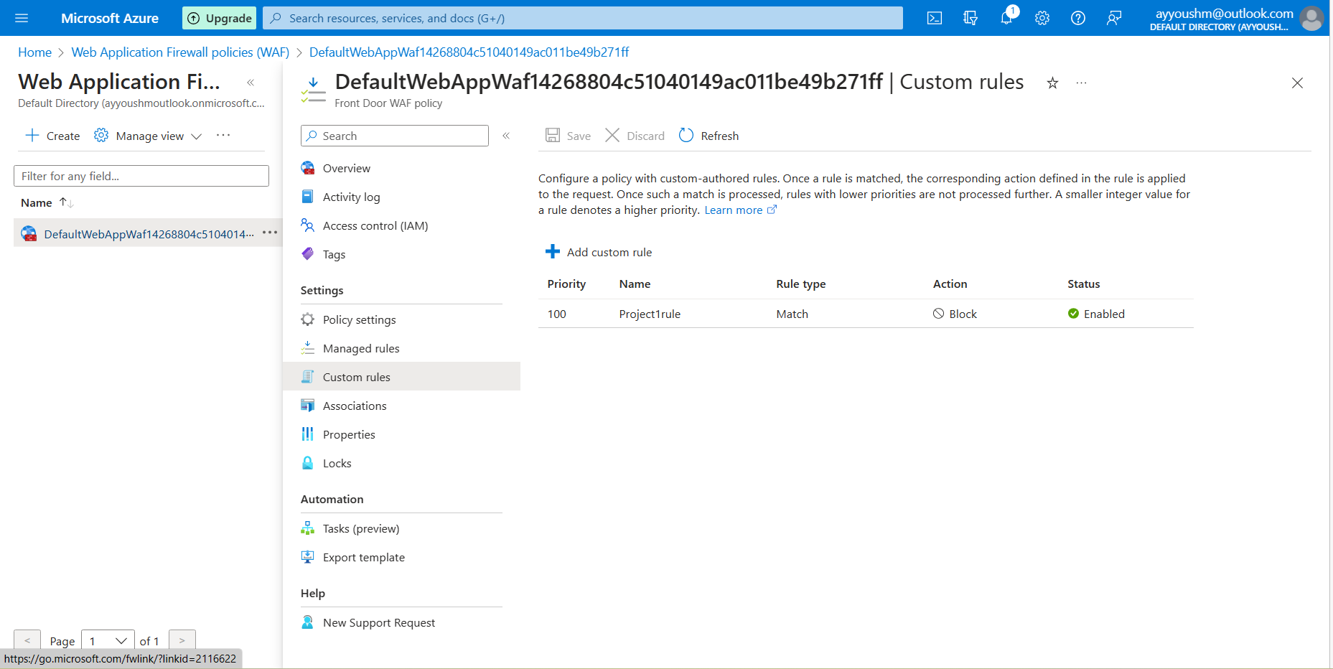

## Disclaimer on Future Charges

Please type “**YES**” after one of the following options:

* ***Maintaining website after project conclusion****: I am aware that I am responsible for any charges that I incur by maintaining my website. I have reviewed the* [*guidance*](https://docs.google.com/document/d/1ZzC4oTJFdlkkeWuzuJAyVSqtDFbuAWilmwXg8PZgzMs/edit) *for minimizing costs and monitoring Azure charges.*
* ***Disabling website after project conclusion****: I am aware that I am responsible for deleting all of my project resources as soon as I have gathered all of my web application screen shots and completed this document.* **YES**

© 2022 Trilogy Education Services, a 2U, Inc. brand. All Rights Reserved.